# Tues, Nov 1

Arsalan K., Katie V., and Narith K. met in the Dan Andreae Math and Writing Centre conference room to discuss servlets, jsp, and the requirements for the project. Narith gave a short lesson about jsp and how it works in a browser, instructing Arsalan and Katie to create a demo jsp project which reads a textfield populated by the user and prints it back to the screen. Then, a list of requirements organized by teacher, student, and admin was written up (show below).

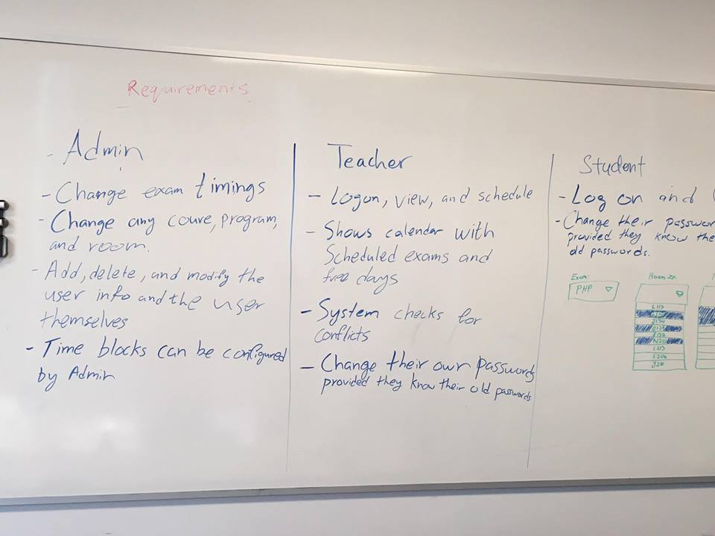

Based on the wording in the Assignment 2 instructions, “After this assignment is finished, the teacher will be able to simply schedule an exam in a room”, it was decided that Narith would create a servlet class to allow the teacher to add an exam to the database, and discuss this with the group afterwards. Katie V. booked private study room 4194 for 10am Thursday, and created a class-wide Slack team with channels for each group (HTML, Servlet, Logic, and Database).

# Weds, Nov 2

Katie V. sent what was given from the HTML team and the Logic team to the Servlet group (still waiting on a response from the database group, as well as contact information for some members of the HTML group).

This consisted of:

* Edit and EditConfirm pages from the HTML team
* EntityClassesForViolet
* LogicClasses for Admin, Exam, Instructor, and Schedule

Narith K. created a basic servlet with a demo html page to add fields populated by a user to a demo database.

# Thurs, Nov 3

Katie V., Dishita P., Narith K., and Arsalan K. met in room 4194 at 10am. Katie created a Github account, and began to brainstorm which classes to create fully and which should be abstract. Narith presented his servlet class to the group, which then discussed and suggested modifications based on the Logic classes that were then implemented. Katie began to write the participation report document, while Narith continued to work on the servlet class. Dishita and Arsalan began modifying the pages provided by the HTML group to allow them to cooperate with Narith’s servlet class.